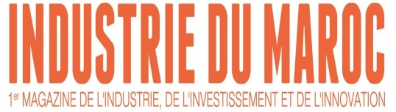

Under the Ministry of Industry, Investment, Commerce and the Digital Economy

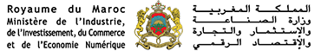

INDUSTRY MEETING DAY MOROCCO
Under the theme:
« Industrial innovation and training for employment creation in the regions»

3rd edition
29 et 30 April 2019
Grand Mogador Hotel
Casablanca

Program of Monday, April 29, 2019
14h00- 15h00 : Registration and visit BtoB area
15h00 : Welcome by Mr. Hicham RAHIOUI, President of the Organizing Committee of Industry Meeting Day
15h30- 18h00 : Official inauguration by
- Moulay Hafid ELALAMY, Minister of Industry, Investment, Trade and Digital Economy
- Said AMZAZI, Minister of National Education, Vocational Training, Higher Education and Scientific Research
- Dr Rosalia ARTEAGA, Ex-president of EQUATEUR
- Salaheddine MEZOUAR, President of CGEM
- Mustapha BAKKOURY, President of the Region Casablanca-Settat
- Abdessamad SEKKAL, President of the Region Rabat-Salé-Kénitra

18h00-18h30 : Coffee break

18H30 : Award Ceremony of the "Industry Awards"

This ceremony, which is part of the Industry Meeting Day, is every year a moment of exchange and conviviality, optimism and encouragement to the emblematic companies of the industrial trades. The best industrial company of the year will be awarded on the basis of its performance and its impact on the local economic fabric and the creation of employment.

20h30 : dinner

Tuesday, April 30, 2019
9H30-10H15 : Adaptation of the training-employment equation
- Loubna TRICHA, Director General OFPPT
- Mohamed FIKRAT, President of FENAGRI
- Karim TAZI, President of the AMITH
- Karim CHEIKH, President of GIMAS
- Mohamed LACHAM, President of AMICA
- Hicham BOUDRAA, Acting Director General AMDIE
- Abed CHAGAR, Vice President of the Federation of Chemistry and Parachemistry
- Tarik AITRI, President of FIMME
- Rahma BOURQIA, Director of the National Evaluation Body at the Higher Council of Education
10H15-11h15 : Keynote

- Dr Rosalia ARTEAGA, Ex-president of EQUATEUR
- Michael HAWES, President FULBRIGHT CANADA
- Dr Ellen BAKER, Astronaut of NASA
- Rebecca GEFFNER, Executive Director of the Moroccan Moroccan Commission for Educational and Cultural Exchange

- Mustapha ACHOUBANE, Director of International Development at the University of Florida

11h15-11h30 : Coffee break

11h30-13h00 : 2nd round table: "The development of industrial zones serving the regions as a catalyst for employment"
- Omar El YAZGHI, Chairman of the Executive Board of CDG Développement
- Abdelghani LAKHDAR, Managing Director of the Millennium Challenge Account-Morocco Agency
- Mounir BENYAHYA, Director of Industrial Parks CFCIM
- Jaafar MRHARDY, Managing Director TMSA MED ZONE
- Nouzha TAARIJI, President of IZDIHAR ASSOCIATION

13h45-14h30 : Lunch break

14h30-16h00 : 3rd round table: "University-business collaboration, a key lever for job development"
- Kamal DAISSAOUI, Président Managing Director EMSI
- Amine BENSAID, Chief Executive Officer of MUNDIAPOLIS
- Noureddine MOUADDIB, President and CEO International University of Rabat
- Abderrahmane FARHATE, ESITH Chief Executive Officer
- Haris Hassabis, Director General of the International University of Casablanca
- Mohammed RHACHI, President of Mohammed V University
- Driss OUAOUICHA, president of Al Akhawayne

